Report for: | Cabinet
Date of Meeting: | 15 February 2024
Subject: | Procurement of Payroll System
Key Decision: | Yes
Responsible Officer: | Alex Dewsnap, Managing Director and Head of Paid Service
Portfolio Holder: | Cllr Stephen Greek, Cabinet Member for Performance, Communications & Customer Experience  Cllr David Ashton, Cabinet Member for Finance and Human Resources
Exempt: | No, except for Appendix 2 which is exempt pursuant to paragraph 3 of Schedule 12A to the Local Government Act 1972 on the grounds that it contains information relating to the financial and business affairs of the council and 3rd party suppliers
Decision subject to Call-in: | Yes
Wards affected: | All
Enclosures: | Appendix 1 – Evaluation Report (anonymised)  Exempt Appendix 2 – Evaluation Report with supplier details and pricing submissions

Section 1 – Summary and Recommendations
This report sets out the procurement undertaken to select a preferred payroll system provider to integrate with the wider Microsoft Dynamics HR & Finance Application

Recommendations:
Cabinet is requested to:

Approve the award of a contract to the recommended provider named in Appendix 2 for Payroll System for a period of up to 3 years, with an option to extend for a period of up to 1 year with effect from April 2024.

Reason: (for recommendations) To ensure continued ability to deliver a payroll service to Council staff and pensioners.

Section 2 – Report

Introductory paragraph
The Council’s existing payroll system provider, Loki Systems, is ceasing UK operations in December 2024 and a replacement is required. In considering this replacement, a wider review of the Council’s HR and Payroll systems roadmap was undertaken.

This report covers the award of contract to a new payroll IT systems provider to support the ongoing provision of payroll services to approximately 2,500 staff and 6,000 pensioners.

Options considered

It is not feasible to “do nothing” as the Council’s existing payroll system provider is ceasing UK operations in December 2024. However, the scale of a payroll replacement project, the close integration between Payroll and HR, and the perception that our Dynamics HR system is currently not optimised, does require us to consider a range of approach options, as follows:

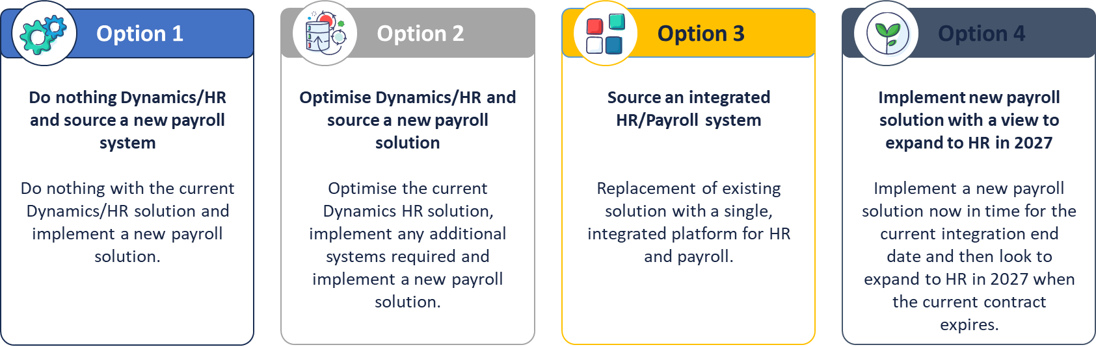

With support from third party Subject Matter Experts (Socitm advisory), a team of officers from HR, Payroll, Pensions, Finance/Procurement and IT assessed each option against the following criteria:

Cost – of each option over 10 years, including implementation, annual licensing and support, and financing

Requirements – How well does each option meet the Council’s functional requirements for Payroll and HR

Strategic fit – How well does each option meet a predefined list of strategic drivers for Harrow (system consolidation, automation user experience, etc)

Feasibility – How achievable is it to implement the chosen option within the timeframe available – ie to complete the payroll replacement by November 2024

The results can be summarised as follows:

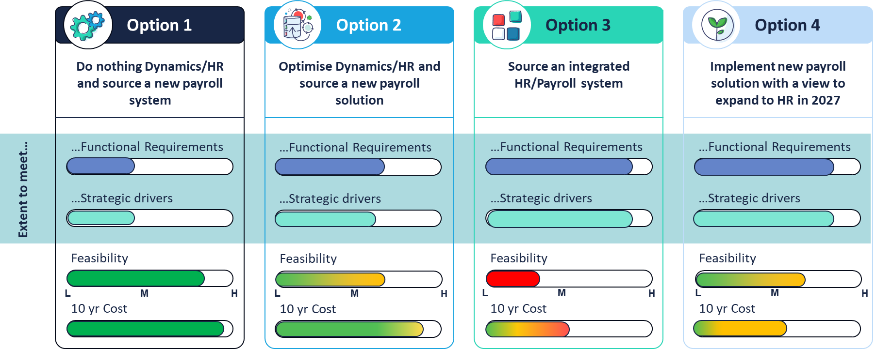

Option 3 (procurement of an integrated HR and Payroll system) does offer the best fit with our HR and Payroll functional requirements and our strategic drivers for system consolidation, automation and user experience. However it is not feasible to safely implement this in the time we have available before our existing payroll ceases. Furthermore the budgetary impact of writing-off the original Dynamics HR project capital cost, earlier than envisaged, makes this unaffordable.

On this basis, Option 2 (source and implement a new payroll solution, and optimise Dynamics), is the immediate recommendation. This does not preclude a future decision to adopt Option 4 (procurement of the HR component of the payroll solution, in place of Dynamics HR), it is suggested that this decision is made in summer 2025.

Background

The Council’s existing Loki payroll system was implemented alongside the wider project, undertaken with Systems Integration Partner PwC in 2020/21-2022/23, to replace SAP with the Microsoft Dynamics Finance and Operations (F&O) solution. Loki were selected in 2020 because they were the only HMRC-compliant UK payroll provider that integrated directly with Dynamics F&O. The Council has used Loki to deliver payroll services to approximately 2,500 staff and 6,000 pensioners since HR and Payroll go-live in April 2022.

Harrow made the decision to adopt Dynamics F&O in April 2020, being the first UK Council to do so. The implementation programme experienced significant challenges and delays. Following final phase go-live in April 2022, a “Fix the Basics” improvement programme was undertaken to address multiple functional issues. A major project to merge the Dynamics HR module with the Dynamics Finance system had to be completed in-line with Microsoft product strategy by a deadline of 31/12/23. It has also been necessary to create a new, highly technical Dynamics support team and to procure a new outsourced IT support partner.

In June 2023, Loki announced that they were ceasing UK Payroll operations from Dec 2024. Following successful completion of the other projects outlined above, the Harrow Dynamics team have prioritised payroll replacement. This work is expected to remain the top priority until completion in November 2024.

To provide confidence in the approach being taken, and to build internal consensus, two concurrent, non-binding G-Cloud “clarification” procurements were undertaken from Dec 23-Jan 24 as follows:

- Payroll only
- HR & Payroll solution

Third party Subject Matter Experts (Socitm advisory) were engaged to support the process, bringing a library of “best practise” requirements from recent ERP procurements undertaken by a wide range of UK Local Authorities and London Councils.

A team of officers from HR, Payroll, Pensions, Finance/Procurement and IT agreed final requirements for both procurements and took part in the soft market testing, demos, evaluation and moderation of supplier proposals. This resulted in a recommended supplier for both Payroll only, and HR & Payroll.

The appraisal included considerations of value for money under the council’s statutory duties. The option adopted constitutes value for money.

Following options appraisal as outlined above the Council will be proceeding to award of contract for the Payroll only procurement (Option 2).

Resources, costs

In addition to the supplier costs set out in Confidential Appendix 2, the Council will incur costs for the third party functional and technical support needed to implement the new system and to augment existing service teams. A detailed Harrow resource plan has been developed to reflect the supplier’s own implementation plan. This includes the following additional capacity:

HR and Payroll Subject Matter Experts (agency) to help define and implement best practise process configuration, and backfill existing staff who will have a project role in User Acceptance Testing and data migration/payroll parallel run data validation
- Business Analyst, data migration and interface development resources (offshore), procured through HCLTech, our existing Dynamics support partners
- Dynamics HR Functional Lead, likely also from HCLTech, to work with HR to define and implement the improvements to the HR system including appraisal, case management, data and insight
- Various additional requirements for support from Loki (for legacy data extract and testing), Digital (recharge for in house BAs), etc

Given the risks associated with tight timelines and our hard deadline, a further 20% contingency has been added to the resource estimate for these client-side costs, in addition to a wider 10% contingency allowance for the project as a whole.

Staffing/workforce
The recently restructured in-house Dynamics team will lead on the implementation of this solution, working alongside the new vendor and HCL. The team has established a credible track record of successful project delivery, including the recent HR merge and other improvements, version upgrades etc. New roles in the new structure, currently vacant and being recruited, will be critical to the delivery of the HR improvements (Option 2), especially the BI developer and lead developer.

Ward Councillors’ comments

N/A

Performance Issues

N/A

Environmental Implications

N/A

Data Protection Implications

Comprehensive requirements have been included in the specification to ensure any new supplier is GDPR compliant, and robust data protection provisions will be included in the contract.

A Full Data Protection Impact Assessment (DPIA) will be carried out with the new service provider.

Risk Management Implications
Risks included on corporate or directorate risk register? No

Separate risk register in place? Yes

The relevant risks contained in the register are attached/summarised below. Yes

The following key risks should be taken into account when agreeing the recommendations in this report:

Risk Description | Mitigations | RAG Status
Target to run November 24 payroll on new system cannot be met due to project delivery delays | - Robust project risk management and governance including the close monitoring of project milestones, regular senior stakeholder & member engagement to address blockers  - 20% contingency added to the resource estimate for client-side costs,  - Plan for and prepare worst case scenario and use the existing payroll software until Mar 25 | Amber
Harrow has insufficient SME (“Subject Matter Expert”) resource to complete project to time | - Approve detailed vendor and Harrow Council/HCL resource plans by end Feb 24, and report on utilization regularly through project governance  - Add a further 20% contingency, as above, to the Harrow resource cost estimates, and delegate authorization of this to Director of IT (in consultation with Cabinet Member for Performance, Communications & Customer Experience) until Nov 24 | Amber
Quality SME/Backfill personnel for the delivery of the project under Option 2 cannot be recruited to or filled in time, delaying the project and placing undue stress on permanent service staff | - Commence recruitment of interim/backfill resources as soon as Cabinet decision approved  - Include service staff in selection processes to ensure quality  - Provide HCL with 6 weeks prior notice for mobilization of their resources | Amber
Future developments in Microsoft Dynamics product strategy and supplier ecosystem drive need for further change | - Strategic meeting with Microsoft Spring ‘24 to ensure Harrow HR roadmap is aligned to product team roadmap and investment  - Aug 25 decision re HR system replacement (Option 4) | Amber
The new supplier has insufficient capacity to take on and successfully deliver the Harrow migration | - Contractual safeguards/ guarantees arising from G-Cloud procurement  - Regular senior engagement with the new supplier during the implementation, to manage resourcing issues | Amber
Failure to improve perception of Dynamics HR with back-office teams and wider managers/staff resulting in continued lack of adoption and self-service process compliance (eg sickness mgmt.) | - Continue to involve HR, Payroll, Pensions Payroll managers as key decision makers in the project  - Reinforce positive “product owner” responsibilities for IT and Service stakeholders working with Dynamics  - Ensure comms and leadership behaviours positively reinforce engagement with and use of the platform | Amber
Payroll cutover mid Financial year causes HMRC complications | - Work with new provider to ensure Harrow approach reflects all relevant successful precedents | Green  (Vendors confirm no expected issues)

Procurement Implications
This procurement has been conducted under the Crown Commercial Service G Cloud 13 Framework (RM 1557.13).

This route was chosen as the G Cloud 13 Framework offers a broad selection of service offerings relevant to this requirement from suppliers ranging from small and medium enterprises to large systems integrators and consultancy firms. It provides an efficient route to market which is fully compliant with the Public Contracts Regulations 2015 and the Council’s Contract Procedure Rules.

The high level evaluation criteria used were:

Quality 70%
Price 30%

Quality consists of Technical Merit & Functional Fit (25%), After Sales
Service Management (25%), and Non Functional (20%)

Due to the nature of the procurement and following consultation with Portfolio Holders and other key stakeholders it was deemed not appropriate to include social value and climate change as evaluation criteria, although all responding suppliers signed up to the Council’s Climate Commitment Charter as part of the process.

Legal Implications
Legal notes Procurement Comments that this procurement has been conducted compliantly under the Crown Commercial Service G Cloud 13 Framework (RM 1557.13).

The G Cloud 13 Framework is current, has been lawfully procured under The Public Contracts Regulations 2015 (PCR), and the services the Council is calling off are in scope.

Compliant call off contracts from lawfully procured framework agreements are a lawful route for the Council to procure services under both the PCR and the Council’s Contract Procedure Rules.

In proceeding to procure under G Cloud 13 Framework, the council has also considered and discharged its legal duty to achieve value for money.

Legal Services can advise on completing the Call Off contract documentation.

Financial Implications
The total cost of the contract is set out in Confidential Appendix 2. The one-off supplier implementation charges (2024/25) will be met from the IT Capital Programme. As shown, a 20% contingency allowance has been added to the contract value to allow for minor projects/changes made within the life of the contract. Any such projects will proceed only subject to approved funding availability.

Year 1 revenue charges (2024/25) of £134,000 covering annual hosting and support plus the one-off budgetary impact of writing-off the Loki implementation capital asset costs earlier than envisaged, will be funded from the Capacity Build/Transformation Reserve.

Year 2 revenue charges (2025/26 and ongoing) will be met from the annual IT revenue budget, which funds the existing payroll solution. The slight increase in charges will be absorbed from wider efficiencies within the IT revenue budget.

Equalities implications / Public Sector Equality Duty
N/A

Council Priorities

- A council that puts residents first

Optimising the Council’s HR and Payroll technology will help to support and further develop and enhance the HR and Payroll services. This will significantly improve the efficiency of internal corporate operations and release capacity for more support to frontline services.

Section 3 - Statutory Officer Clearance
Statutory Officer: Sharon Daniels
Signed by the Chief Financial Officer

Date: 26/01/2024
Statutory Officer: Nhlanhla Mahlangu
Signed on behalf of the Monitoring Officer

Date: 25/01/2024
Chief Officer: Alex Dewsnap
Signed off by the Managing Director

Date: 26/01/2024
Head of Procurement: Nimesh Mehta
Signed on behalf of the Head of Procurement by Carol Barlow

Date: 24/01/2025
Interim Risk Manager: Neale Burns
Signed on behalf of the Interim Head of Internal Audit

Date: 25/01/2024

Has the Portfolio Holder(s) been consulted? Yes ☒

Mandatory Checks

Ward Councillors notified: NO, as it impacts on all Wards

EqIA carried out: NO

Section 4 - Contact Details and Background Papers
Contact: Ben Goward, Director of ICT, Ben.Goward@harrow.gov.uk
Background Papers: None

Call-in waived by the Chair of Overview and Scrutiny Committee
(for completion by Democratic Services staff only)
NOT APPLICABLE*

